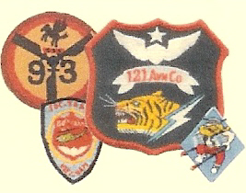
121st AVN Association Volume Number 9 Issue Number 1 Date 15 February 2019

From the Editor’s Desk

Another year has passed, and our Kansas City reunion is approaching. This looks like another great reunion, and this time it is in the middle of America. With your help this will be our best reunion ever. John Schmied describes this in more detail in his article below. We encourage you to bring your children and grandchildren to our reunions. They are sure to learn things about you that you have been too modest to tell them, and it will be good for them to learn what sort of men you hung out with. It is about time that they learned that when Grandpa was their age he was a bigger BADASS than any of the so-called heroes that Hollywood gives them To this end we have included Kelly Cunningham’s article about her father.

And keep your stories coming in! Bob Greene needs them for the archives and we need to hear them to help us remember what we were when we were young soldiers.

Secretary’s Report

By now everyone should have received the reunion announcement that was mailed on January 2. If you have not received it, you may download the information and registration form from our web site: http://121avn.org or contact John Schmied at johndschmied@yahoo.com or call – 352-633-0541.
Please remember the registration forms must be mailed no later than April 11, to allow time for it to be processed.
Be advised that the hotel address on the reunion flyer is incorrect: The correct address for the hotel is 8801 NW 112th St. After several proofreads, somehow that error was not discovered until after it was mailed out. We apologize for any inconvenience.
For information on the host hotel, The Hilton Kansas City Airport Hotel, please visit: https://www3.hilton.com/en/hotels/missouri/hilton-kansas-city-airport-MCIAPHF/index.html
There has been some confusion with the hotel reservations. If you call the Hilton Reservations number listed on your reunion flyer and you are told that there are no rooms left at our group rate, please call the hotel direct and speak to Trish. Her direct number is 816-801-5285.
The hotel provides an airport shuttle to and from the airport that runs on a regular basis. The hotel is only 8 - 10 minutes from the airport.
The hotel also provides regular shuttle service to a huge shopping plaza, The Zona Rosa (www.zonarosa.com). Please check with the hotel concierge for the shuttle schedule.
A breakfast buffet is included in your room rate at the hotel restaurant the Asado Urban Grill.
We have arranged for some entertainment before and after our dinner on Friday evening (April 26). The KC Bettys will be performing a “USO style show” some music from our era. Everyone will have the opportunity to have their picture taken with one of The Bettys along with a big red lip print on your cheek! The music and comedy routines are supposed to be great! This group’s function is to raise funds for the Honor Flights and all the Bettys are escorts on most of the Honor Flights.
Our hospitality room will be in the Osage B-C Ballroom and our dinners will be in the Wyandot Ballroom. We will have a cocktail hour with a cash bar before dinner both evenings.
Our annual membership meeting will be held Saturday morning (April 27), where among other things, we will discuss possible locations for our 2020 reunion.
For the ladies: We have a Parlor room available for our use throughout the reunion. The ladies may want to gather there to relax, or plan their outings.
Plans are in the early stages for a possible trip to Weston Mo, https://www.westonmo.com/ for a day of browsing the crafty shops and lunch. Also there is a possibility of a trip to Independence, Mo https://www.trumanlibrary.org/hours.htm to visit the Harry Truman Library and Museum and the home Harry and Bess Truman lived in before and after his presidency. https://www.nps.gov/hstr/index.htm more information about these excursions will be available when you register in the hospitality room.
Kansas City has a plethora of museums and tourist attractions, to satisfy anyone’s interest. We will have travel brochures in the hospitality room. Hope you have the opportunity to take advantage of all the city has to offer.
Hope to see you in Kansas City in April.
John Schmied,

Historian’s Report
Version 8 of our archive is now closed and is being edited by Jack Carey to insure quality. Having Jack on board is great because he has been able to identify and repair many photos digitized from slides that were backwards. He also identified several H-21s which display a tiger’s head with a red lightening bolt instead of blue or white. Since the 93rd Trans had three platoons, it would seem logical that at some point there were red, white, and blue platoons. Probably the red platoon became the Vikings when the UH-1B gunships came on line. I mentioned this to Jerry Daly and he agreed. He said the change was happening when he arrived at Soc Trang for the first time.
As soon as Jack finishes reviewing Version 8, I will get it off to Texas Tech and start loading a few things into Version 9. Jack and I will be prepared to tell you about where we are to date at Kansas City, but we know there are still some of you who have photos, stories, or other materials that need to be in our Archive. In fact, Jerry Zynda just sent me a cigar box full of slides (probably about three hundred) last week. Jerry and I flew together during our tour, so I’m looking forward to seeing his slides.
Hope to see most of you in Kansas City, but, if for some reason you can’t come, feel free to send materials to me at:
Bob Greene
47296 Grandview Place
Potomac Falls, VA 20165

Academic Financial Assistance (Scholarship) Program

After establishing and being the Point of Contact person for our scholarship program since its inception, John Kennedy has asked to step down. We thank John for his hard work and diligence for making this program a huge success for the descendants of our members.
The Board has agreed to appoint John Schmied to be the point of contact to handle the scholarship program beginning this year. The forms on the web site have been revised to update the address where the applications are to be sent. Please visit http://121avn.org/ then click on the Scholarship Instructions on the menu on the left, to download the forms. We will also have the information available at the reunion.

Quilt of Valor

The Quilt of Valor is a project of The Quilt of Valor Foundation whose mission is:
To cover service members and veterans touched by war with comforting and healing Quilts of Valor. This is the presentation of Dave Cunningham’s Quilt of Valor, lovingly recorded by his daughter Kelly.

When you are a child growing up with a Dad that is a Vietnam Veteran you don’t realize what all that encompasses. I remember my Dad did not talk about Vietnam when I was younger and I really did not understand why. It was not until I was older and I started attending the 121 AVN Reunions with him that I heard stories from him , his friends and other members of his organization that I began to understand a little more why he did not say much when I was younger. I remember thinking after attending my first couple of reunions if there is one thing I wish I could do it was to give all the Vietnam Veterans (including my Dad) the “Welcome Home” they never received. I have learned from attending the 121 AVN reunions that the organization is made up of some truly humble, amazing, proud Veterans.
My Dad is one of those people. My Dad will tell you he proudly served this country and would never ask for anything in return. I knew I could not give my Dad a “Welcome Home” party like he deserved but I still wanted to do something special. I mentioned this to close friends of our family – Linda and Rick Weimar. Linda introduced me to something called the “Quilt of Valor.” The “Quilt of Valor” is a quilt that is given to an active duty or veteran to honor them for their service. When the quilt is presented to the person receiving it you talk about their time in the service and when you are finished with your presentation you wrap the quilt around the person’s shoulders. My first thought was what an amazing concept and how perfect it would be for my Dad to experience such a moment. Thankfully the Weimar’s and their supportive friends offered to create the quilt for my Dad. After many hours of hard work, creativity and determination a quilt made from love and friendship was completed. On October 19, 2018 in Maggie Valley, North Carolina Rick and Linda Weimar presented my Dad with the “Quilt of Valor.” I don’t think I could honestly write how much it meant to me, my father, mother and family the effort that was made by the Weimar’s and their friends to make this moment happen. It will forever be a moment that I shared with my Dad that I will always cherish. Welcome Home Captain David E. Cunningham.
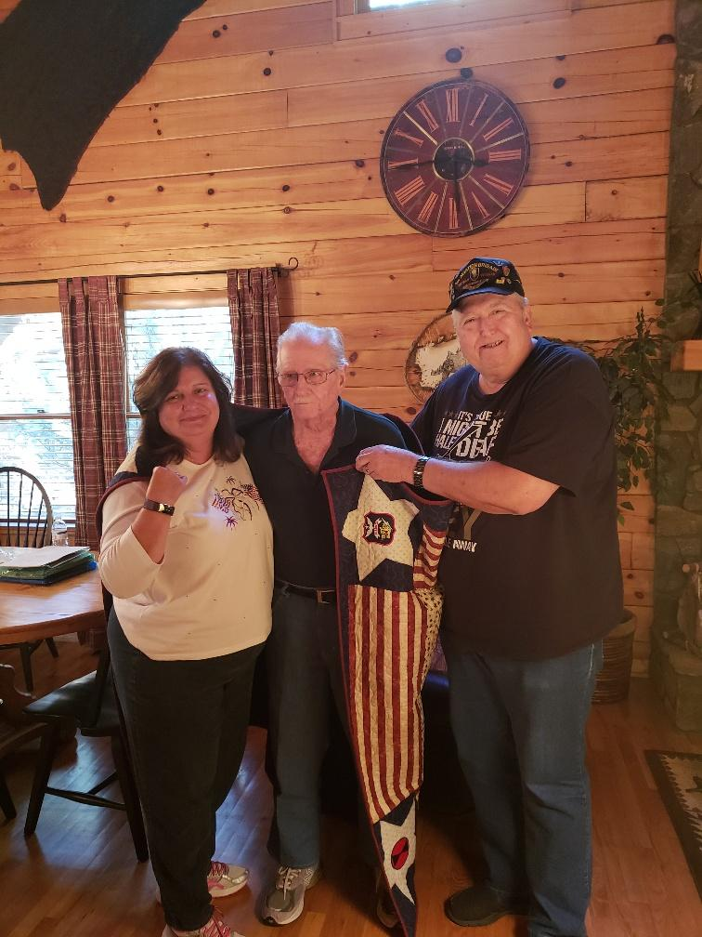
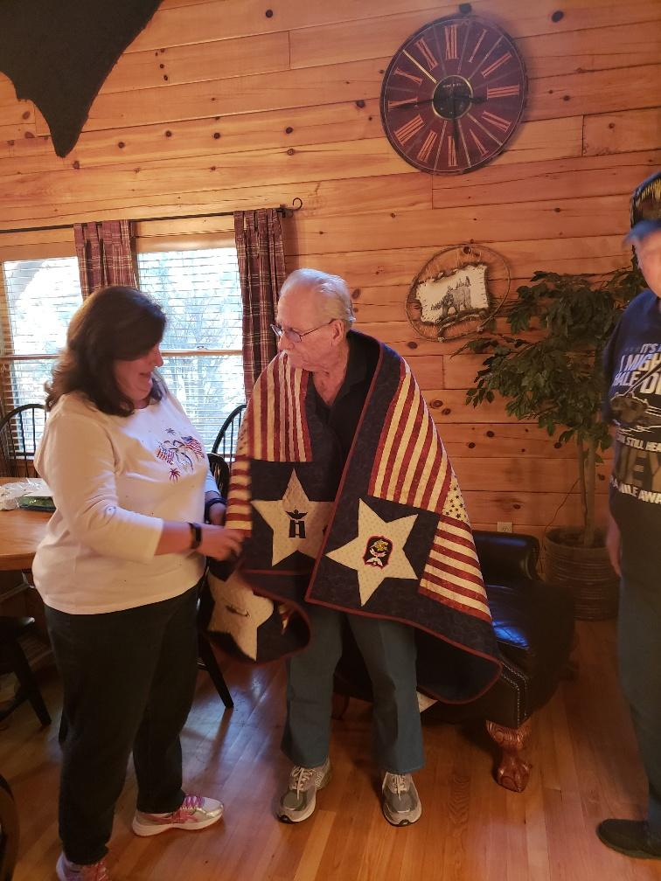

My Moment in History

In February 1968 I was crewing the alternate C&C helicopter. This mostly meant that it had a bunch of extra radios that I did not know how to operate, but also meant that it got selected for a lot of VIP missions. On 26 February 1968 we were assigned to the Navy to operate from the USS Benewah which was anchored at Can Tho. Our passenger was the Commander Task Force (CTF) 117, who used the Benewah as his flagship, and we had done our usual superb job of taking him wherever he wanted to go. That afternoon, as we were returning him to The Benewah we were second to land after another
UH-1. The LSO waved that helicopter off when he was on final approach, and we touched down lightly upon the helipad on the stern of the ship. The next thing I knew a Photographer was taking our picture, another sailor was asking me the names and rank of all of our crew members and another was thrusting a piece of the best cake I had seen in a year and a half into my hands while yet another was handing me a Coke. It seems that we had made the 1000th Helicopter Landing upon the ship, and the Navy celebrates things like that. A few days later each of us received a Zippo cigarette lighter engraved with the coat of arms of the Benewah, our names and the notation:1000th Helo Landing. That happened on my 21st birthday, and was ten days from the end of my time in Viet Nam, so was a nice way to stand down. Sadly, someone stole the lighter when I lived in Nashville, but the memory remains.

Don Jackson

IN Memoriam

Sometimes we do not learn of the death of our comrades for weeks, months or even years after they pass. The following is a list of those reported to us who have passed, with the information we have about them:

Roy Amerson – Door Gunner & Crew Chief – Served in Soc Trang in 66 – 67. Died 2/21/2016.
Terry Bryan – Dental Assistant – Died 8/1/2017 - 36th Dental Det. - served in Soc Trang in 66-67, Life Member of the Association.
John K. Carpenter – 1st Sgt. – Died 10/12/2017 – He was the last 1st Sgt. Of the 121st and furled the colors when the unit stood down.
John Colgan – Mail Clerk – 69 – 70 – Died 10/1/2017.
Gary Dowler – Pilot – Served in Soc Trang in 66 – 67 – Life Member of Association – Died 9/24/2016.
William Fonshell – Died 5/13/2016.
James E. Gray – Pilot – C. O. of the 93rd in Da Nang – Died 11/13/2017.
Gary Heffner – H–21 Pilot & Platoon Commander – served with the 93rd – 121st in 63 – 64 Died 2/6/2017.
Gerald Herman – Died 10/31/2017.
John (Jack) Hurley – Served with the 57th Maintenance Det. 1969. Died 2/3/21018.
Freddie Kemp – B/T Pilot & Ops Officer – 66 – 67– Life Member and Former Secretary of our Association – Died 11/13/2017.
Charles S. Kettles – Pilot & C. O. of 121st in 19569 – Life Member and Congressional Medal of Honor Recipient.
John Kidney – Pilot – 65 -66 – Died 1/1/2018.
Frank “Ernie” Miller – Door Gunner in 66 – 67. Life Member of Association – Attended most reunions and assisted with setting up the Tucson Reunion in 2017. Died 11/17/2018.
Clifford Mitchel – Viking Pilot – 65 – 66 – Died 1/1/2016.
Joseph Ollar – Maintenance – 69 – 70 – Died 1/9/2016.
Robert Pressley – Maintenance – 121st & 80th – 65 – 66 – Died 12/3/2018.
Michael P. Quaintance – Pilot – 69 – Died 12/18/16.
James J. Ridge – Crew Chief – 69 – 70 – Died 4/1/2017.
Kenneth Schmitz – 80th & 93rd – Served in our units in the mid 50’s in Ft. Riley, KS. Died 9/1/2017.
Ronald Shefchik – 80th & 93rd – Served with our units in the mid 50’s in Ft. Riley, KS. Died 5/14/2016.
William T. (Tom) Slye – Pilot - 80th & 121st – 63 – 64 – Life Member of Association. Died 2/28/2018.
Earl Smith – Pilot - 67 – 68 – Died 5/14/2017.
Gene Turechek – 80th & 93rd – Served with our units in 1954 in Ft. Riley, KS. Died 4/23/2016.
Emmett J. Williams – Maintenance Mechanic – Died 7/15/2017
Bill Wilson – Pilot – 65 – Life Member of Association – Died 2/11/2018
John Winsor – White Tiger Door Gunner 66 – 67 – Life Member of Association – Died 1/27/2017.

Coming Net Issue:
Jack Mason has graciously sent pictures of Tuffy the Tiger, as well as an article about Award Ceremony performed after the 93rd became the 121st. We look forward to giving you this article.

Contact Us:

Letters to the editor should be sent to:
Donald Jackson, Editor
1155 Union Road
Greeneville, Tn. 37745
Email: Tiger129ts@aol.com

Your Board of Trustees is:

Donald Jackson, Chairman Robert Greene, Vice Chairman & Historian
Tiger129ts@aol.com bojogreene@gmaill.com

John Schmied, Secretary & Dave Cunningham, Treasurer and Membership
Scholarship Coordinator Tigerlead67@aol.com
johndschmied@yahoo.com

John Kennedy, Trustee Rick Weimar, Trustee &
cudzuekennedy@gmail.com Membership Committee
rl194954@aol.com

Phil Olson, Trustee Fred Lammers, Trustee &
philo5907@gmail.com Membership Committee
fjlammers@msn.com
Jack Carey, Trustee
jack.j.carey@gmail.com

